苏州大学实验报告
院、系 | 计科院 | 年级专业 | 软件工程 |  | 姓名 | 高歌 | 学号 |  | 2030416018
课程名称 | 数据库课程实践 |  |  |  |  |  | 同组实验者 |  | /
指导教师 | 瞿剑锋 | 实验日期 |  | 2022-03-23 |  | 成绩

实 验 名 称 | SQL语言（试验七）SQL查询语句

试验七 SQL查询语句
目的: 掌握 Select 查询语句。

一、单表
1 查询年龄在19至21岁之间的女生的学号,姓名,年龄,按年龄从大到小排列。
- SELECT Sno, Sname, Sage
- FROM Student
- WHERE Sage BETWEEN 19 AND 21 AND Ssex = '女'
- ORDER BY Sage DESC;
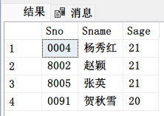
2 查询姓名中第2个字为“明”字的学生学号、性别。
- SELECT Sno, Ssex
- FROM Student
- WHERE Sname LIKE '_明%';
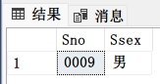
3 查询 1001课程没有成绩的学生学号、课程号
- SELECT Sno, Cno
- FROM SC
- WHERE Cno = '1001' AND Grade IS NULL;
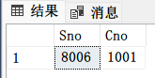
4 查询JSJ 、SX、WL 系的年龄大于25岁的学生学号,姓名，结果按系及学号排列
- SELECT Sno, Sname
- FROM Student
- WHERE Sdept IN ('JSJ', 'SX', 'WL') AND Sage > 25
- ORDER BY Sdept, Sno;
5 按10分制查询学生的Sno,Cno,10分制成绩
（1-10分为1，11-20分为2，21-30分为3，… 91-100为10）
- SELECT Sno, Cno, Grade / 10 + 1
- FROM SC;
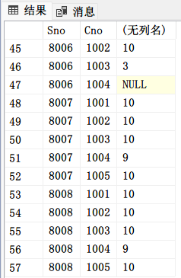
6 查询Student 表中的学生共分布在那几个系中。（distinct）
- SELECT DISTINCT Sdept
- FROM Student;
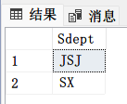
7 查询0001号学生1001，1002课程的成绩。
- SELECT Cno, Grade
- FROM SC
- WHERE Sno = '0001' AND Cno IN ('1001', '1002');
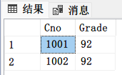
二、统计
*注：下面的查询结果改用VSCode演示。
1 查询姓名中有“明”字的学生人数。
- SELECT COUNT(*) AS count
- FROM Student
- WHERE Sname LIKE '%明%';
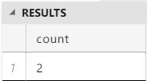
2 计算‘JSJ’系的平均年龄及最大年龄。
- SELECT AVG(Sage) AS Sage_avg, MAX(Sage) AS Sage_max
- FROM Student
- WHERE Sdept = 'JSJ';
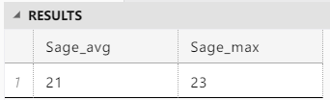
3 查询学生中姓名为张明、赵英的人数
- SELECT COUNT(*) AS name_count
- FROM Student
- WHERE Sname IN ('张明', '赵英');
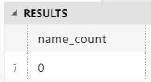
4 计算每一门课的总分、平均分，最高分、最低分，按平均分由高到低排列
- SELECT Cno, SUM(Grade), AVG(Grade), MAX(Grade), MIN(Grade)
- FROM SC
- GROUP BY Cno
- ORDER BY AVG(Grade) DESC;
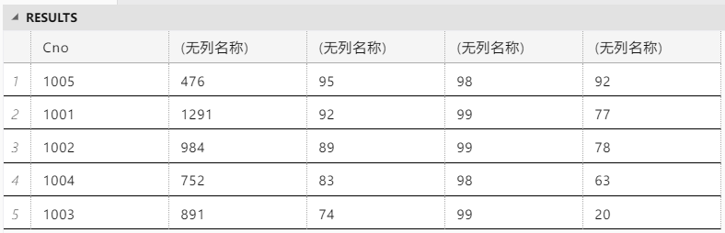
5 计算 1001,1002 课程的平均分。
- SELECT Cno, AVG(Grade) AS avg_grade
- FROM SC
- WHERE Cno IN (1001, 1002)
- GROUP BY Cno;
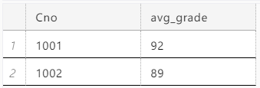
6 查询平均分大于80分的学生学号及平均分
- SELECT Sno, AVG(Grade)
- FROM SC
- GROUP BY Sno
- HAVING AVG(Grade) > 80;
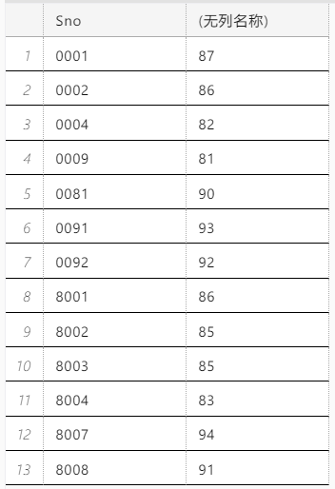
7 统计选修课程超过 2 门的学生学号
- SELECT Sno
- FROM SC
- GROUP BY Sno
- HAVING COUNT(*) > 2;
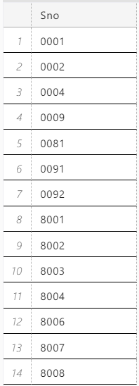
8 统计有10位成绩大于85分以上的课程号。
- SELECT Cno
- FROM SC
- WHERE Grade > 85
- GROUP BY Cno
- HAVING COUNT(*) >= 10;
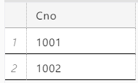
9 统计平均分不及格的学生学号
- SELECT Sno
- FROM SC
- GROUP BY Sno
- HAVING AVG(Grade) < 60;
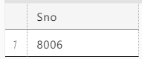
10 统计有大于两门课不及格的学生学号
- SELECT Sno
- FROM SC
- WHERE Grade < 60
- GROUP BY Sno
- HAVING COUNT(*) > 2;

三、连接
1 查询 JSJ 系的学生选修的课程号
- SELECT DISTINCT Cno
- FROM Student NATRUAL JOIN SC
- ON Sdept = 'JSJ';
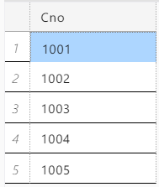
2 查询选修1002 课程的学生姓名 (不用嵌套及嵌套2种方法）
- SELECT Sname
- FROM Student, SC
- WHERE Student.Sno = SC.Sno AND Cno = '1002';
- SELECT Sname
- FROM Student
- WHERE Sno IN (SELECT Sno
- FROM SC
- WHERE Cno = '1002');
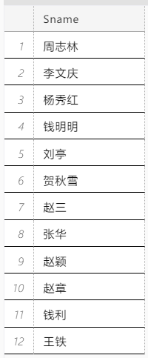
3 查询数据库原理不及格的学生学号及成绩
- SELECT Sno, Grade
- FROM SC, Course
- WHERE SC.Cno = Course.Cno
- AND Cname = '数据库原理'
- AND Grade < 60;
4 查询选修“数据库原理”课且成绩 80 以上的学生姓名(不用嵌套及嵌套2种方法）
- SELECT Sname
- FROM Student, SC, Course
- WHERE Student.Sno = SC.Sno
- AND SC.Cno = Course.Cno
- AND Cname = '数据库原理'
- AND Grade > 80;
- SELECT Sname
- FROM Student
- WHERE Sno IN (SELECT Sno
- FROM SC
- WHERE Grade > 80
- AND Cno IN (SELECT Cno
- FROM Course
- WHERE Cname = '数据库原理'));
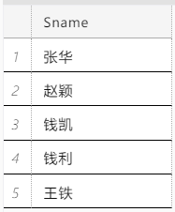
5 查询平均分不及格的学生的学号，姓名,平均分。
- SELECT Student.Sno, MAX(Sname), AVG(Grade)
- FROM Student, SC
- WHERE Student.Sno = SC.Sno
- GROUP BY Student.Sno
- HAVING AVG(Grade) < 60;
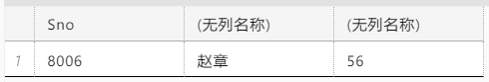
6 查询女学生平均分高于75分的学生姓名。
- SELECT MAX(Sname), AVG(Grade)
- FROM Student, SC
- WHERE Student.Sno = SC.Sno
- AND Ssex = '女'
- GROUP BY Student.Sno
- HAVING AVG(Grade) > 90;
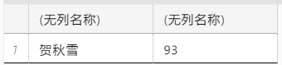
7 查询男学生学号、姓名、课程号、成绩。(一门课程也没有选修的男学生也要列出，不能遗漏)
- SELECT Student.Sno, Sname, Cno, Grade
- FROM Student LEFT JOIN SC
- ON Student.Sno = SC.Sno
- AND Ssex = '男';
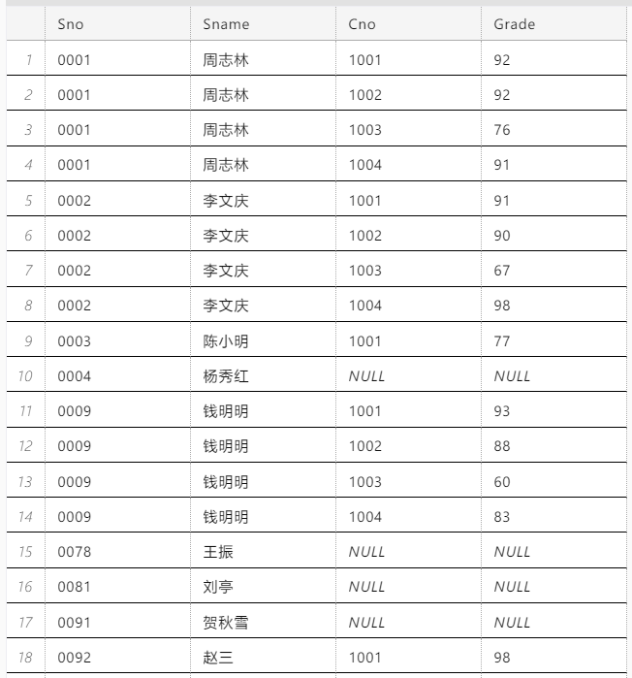
（只列出了一部分）

四、嵌套、相关及其他
1 查询平均分不及格的学生人数
- SELECT COUNT(*)
- FROM Student
- WHERE Sno IN (SELECT Sno
- FROM SC
- GROUP BY Sno
- HAVING AVG(Grade) < 60);
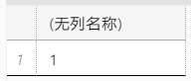
2 查询没有选修1002 课程的学生姓名
- SELECT DISTINCT Sname
- FROM Student
- WHERE Sno NOT IN (SELECT Sno
- FROM SC
- WHERE Cno = '1002');
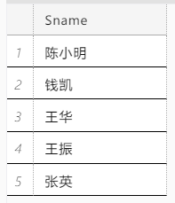
3 查询平均分最高的学生学号及平均分 （2种方法 TOP, any, all）
- SELECT TOP 1 Sno, AVG(Grade)
- FROM SC
- GROUP BY Sno
- ORDER BY AVG(Grade) DESC;
- SELECT Sno, AVG(Grade)
- FROM SC
- GROUP BY Sno
- HAVING AVG(Grade) >= ALL(SELECT AVG(Grade)
- FROM SC
- GROUP BY Sno);
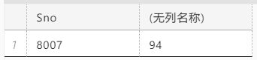
*4 查询没有选修1001，1002课程的学生姓名。
- SELECT Sname
- FROM Student
- WHERE Sno NOT IN (SELECT Sno
- FROM SC
- WHERE Cno IN ('1001', '1002'));
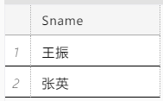
5 查询1002课程第一名的学生学号（2种方法）
- SELECT TOP 1 Sno
- FROM SC
- WHERE Cno = '1002'
- ORDER BY Grade DESC;
- SELECT Sno
- FROM SC
- WHERE Cno = '1002'
- AND Grade >= ALL(SELECT Grade
- FROM SC
- WHERE Cno = '1002');
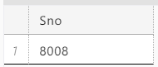
6 查询平均分前三名的学生学号
- SELECT TOP 3 Sno, AVG(Grade)
- FROM SC
- GROUP BY Sno
- ORDER BY AVG(Grade) DESC;
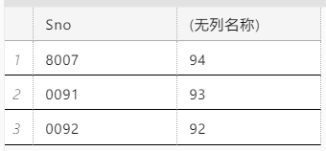
7 查询 JSJ 系的学生与年龄不大于19岁的学生的差集
- SELECT *
- FROM Student
- WHERE Sdept = 'JSJ'
- EXCEPT (SELECT *
- FROM Student
- WHERE Sage < 19);
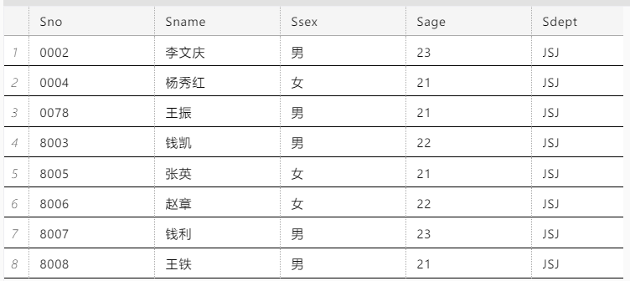
8 查询1001号课程大于90分的学生学号、姓名及平均分大于85分的学生学号、姓名
- SELECT Student.Sno, Sname
- FROM Student, SC
- WHERE Cno = '1001'
- AND Grade > 90
- UNION
- SELECT Student.Sno, MAX(Sname)
- FROM Student, SC
- WHERE Student.Sno = SC.Sno
- GROUP BY Student.Sno
- HAVING AVG(Grade) > 85;
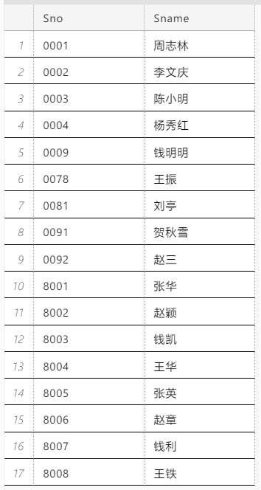
9 查询每门课程成绩都高于该门课程平均分的学生学号
- SELECT DISTINCT Sno
- FROM SC
- WHERE Sno NOT IN (SELECT Sno
- FROM SC AS S
- WHERE Grade <= (SELECT AVG(Grade)
- FROM SC
- WHERE Cno = S.Cno));
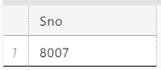
10 查询大于本系科平均年龄的学生姓名
- SELECT Sname
- FROM Student AS S
- WHERE Sage > (SELECT AVG(Sage)
- FROM Student
- WHERE Sdept = S.Sdept);

